**Topics: Normal distribution, Functions of Random Variables**

1. The time required for servicing transmissions is normally distributed with *μ* = 45 minutes and *σ* = 8 minutes. The service manager plans to have work begin on the transmission of a customer’s car 10 minutes after the car is dropped off and the customer is told that the car will be ready within 1 hour from drop-off. What is the probability that the service manager cannot meet his commitment?
2. 0.3875
3. 0.2676
4. 0.5
5. 0.6987

Sol: *μ* = 45, *σ* = 8 minutes, X=60-10=50

Code:

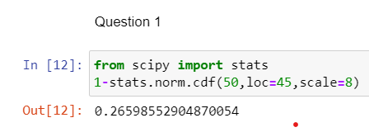

Output: 0.2659

1. The current age (in years) of 400 clerical employees at an insurance claims processing center is normally distributed with mean *μ* = 38 and Standard deviation *σ* =6. For each statement below, please specify True/False. If false, briefly explain why.
2. More employees at the processing center are older than 44 than between 38 and 44.
3. A training program for employees under the age of 30 at the center would be expected to attract about 36 employees.

Sol: A: Statement A is False because probability of employees aged more than 44 is lesser than the probability of people aged between 38 and 44.

Code: from scipy import stats

1-stats.norm.cdf(44,loc=38,scale=6)

Output: 0.158

stats.norm.cdf(44,loc=38,scale=6)-stats.norm.cdf(38,loc=38,scale=6)

Output: 0.341

B: Statement B is True as it is evident from the probability calculations as below.

Code: stats.norm.cdf(30,loc=38,scale=6)

Output: 0.091

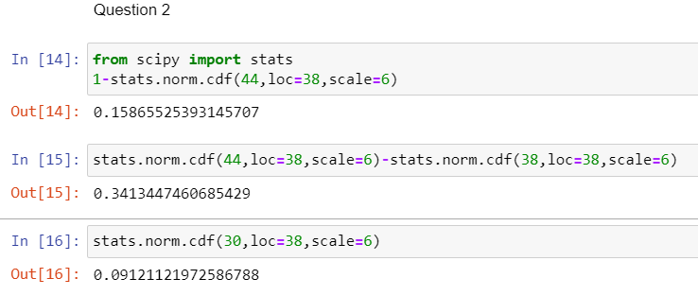

So chance= 0.091*400=36.48

1. If *X1* ~ *N*(μ, σ2) and *X*2 ~ *N*(μ, σ2) are iid normal random variables, then what is the difference between 2 *X*1 and *X*1 + *X*2? Discuss both their distributions and parameters.

Sol: According to the **Central Limit Theorem**, any **large sum** of **independent**, **identically distributed(iid)** random variables is approximately **Normal**.

Hence Let X= N(µ, σ2) and

2X1=X1+X1= 2X(N(µ, σ2))=N(2µ, 4σ2)

X1+X2= N(µ+ µ, σ2+ σ2)= N(2µ, 2σ2)

2X1-(X1+X2)=N(0, 6σ2)

Here if we compare 2X1 and X1+X2, inference can be drawn that mean is same for both where as variance of 2X1 is double the variance of X1+X2

1. Let X ~ N(100, 202). Find two values, *a* and *b*, symmetric about the mean, such that the probability of the random variable taking a value between them is 0.99.
2. 90.5, 105.9
3. 80.2, 119.8
4. 22, 78
5. 48.5, 151.5
6. 90.1, 109.9

Sol: Code:

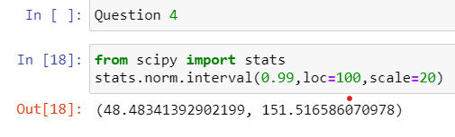

Output: (48.48, 151.51)

Hence option D is correct.

1. Consider a company that has two different divisions. The annual profits from the two divisions are independent and have distributions Profit1 ~ N(5, 32) and Profit2 ~ N(7, 42) respectively. Both the profits are in $ Million. Answer the following questions about the total profit of the company in Rupees. Assume that $1 = Rs. 45
2. Specify a Rupee range (centered on the mean) such that it contains 95% probability for the annual profit of the company.

Sol

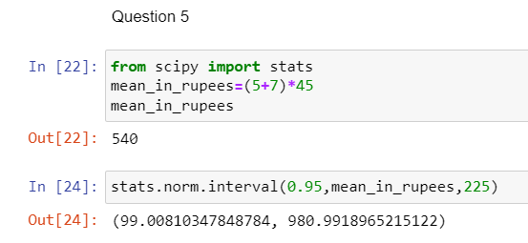

Output: (99.00, 980.99)

1. Specify the 5th percentile of profit (in Rupees) for the company

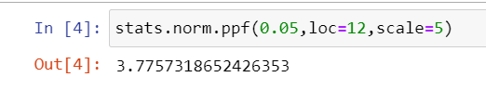

1. Which of the two divisions has a larger probability of making a loss in a given year?

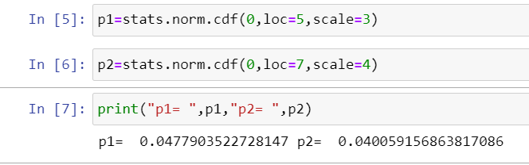

Sol: From the output we can infer that first division has more chance of loss than division 2.